Service Manual
TMF No Frost Series
Applicable Models | Product Models | Customer model
HD-668FWEN | UR-BCD512WE-SQ | NS-RTM18SS2  NS-RTM18WH2

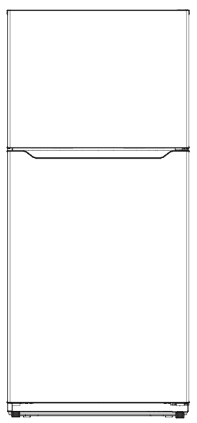

The picture in this service manual is only for reference, and specific appearance and configuration are subject to the real product.
This manual mainly teaches the method, the specific work skill needs engineer to accumulate through the daily work.

 WARNING
Important Safety Notice
There are special components used in this equipment which are important for safety. These parts are marked by in the Schematic Diagrams, Circuit Board Diagrams, Exploded Views and Replacement Parts List. It is essential that these critical parts should be replaced with manufacturer’s specified parts to prevent shock, fire or other hazards. Do not modify the original design without permission of manufacturer.

 WARNING
Important Safety Notice
The Maintenance Manual is only for the use of maintenance personnel with certain experience and background in electrical, electronic and mechanical field.
Any attempt to repair main devices may lead to personal injury and property loss.
Manufacturers or distributors are not responsible for the content of the Manual and interpretation thereof.

Midea Refrigerators
Technical Maintenance Manual
Copyright @2017
All rights reserved. Replication of all or part of the Manual in any forms shall not be allowed without written approval by the Overseas Sales Corporation of Midea Refrigerators.

- Contents
1. Significant update notes (None) 5
2. Safety Warning 6
2.1 Warning for operation safety 6
2.2 Safety instruction for refrigerant 8
3. Installation and commissioning 9
3.1 Handling 9
3.2 Door Disassembly and Assembly 9
3.3 Installation location 9
3.4 Leveling of the refrigerator 10
3.5 Left or right open door reversal 10
3.6 Installation of handle（Option） 12
4. Main parts and external dimension 14
4.1 Main parts 14
4.2 External dimension 15
4.3 Midea product serial number and location 15
5. Electric control system 17
5.1 Electrical parts parameters 17
5.2 Circuit diagram 18
5.3 Main PCB terminal connection diagram 19
6. Refrigeration system 20
6.1 Refrigeration system working principle 20
6.2 Cooling pipeline and drain pipe inside the cabinet 20
6.3 Circulating route of cooling air 21
6.4 Welding points in chambers or foam layer 21
6.5 Welding point in the compressor case 22
7. Dismantling of parts 23
7.1 Parts on the door 23
7.2 Parts inside the refrigerator 24
7.3 Light system 24
7.4 Air duct components refrigerating chamber and fan motor 26
7.5 Air duct components in freezing chamber and fan motor 26
7.6 Evaporator and Defrost system 27
7.7 Compressor case 28
7.8 Display control board 32
7.9 Main control board 32
8. Temperature sensing system 34
8.1 Position of sensors 34
8.2 Replacement of sensors 34
8.3 Sensor without terminal replacement 35
8.4 Sensor R/T table 36
9. Function and operation 38
9.1 Display operation panel 38
9.2 Temperature control 38
9.3 Mode setting 39
9.4 Defrosting function 39
9.5 Open door alarm (None) 39
9.6 Error code and solutions 39
9.7 Test mode 40
9.8 Demo mode（None） 40
9.9 Backup data for power fail 40
10. Compressor 41
10.1 Compressor on and off control specifications 41
11. Troubleshooting Method 42
11.1 No cooling (Air cooling-Electronic) 42
11.2 No working of compressor 44
11.3 Inside frosting, no defrosting 45
11.4 Inside frosting, no defrosting-Maintenance guidelines 46
11.5 Light is not on 47
11.6 Fan failure 48
11.7 Defective defrost circuit 48
11.8 Noise 49
11.9 Air duct not operated 49
12. Product exploded view and spare parts list 50

Significant update notes (None)

2. Safety Warning

2.1 Warning for operation safety
Important Safety Instructions
 | CAUTION  RISK OF ELECTRIC SHOCK  DO NOT OPEN | 
 | This symbol indicates that dangerous voltage constituting a risk of electric shock is present within your freezer.
 | This symbol indicates that there are important operating and maintenance instructions in the literature accompanying your freezer.
WARNING
1) Read these instructions.
2) Keep these instructions.
3) Heed all warnings.
4) Follow all instructions.
5) Do not use this appliance near water.
6) Clean only with a damp cloth.
7) Do not block any ventilation openings.
8) Install in accordance with the manufacturer’s instructions.
9) Do not install near any heat sources, such as radiators, heat registers, stoves, or other apparatus that produce heat.
10) Do not defeat the safety purpose of the polarized or grounding-type plug. A polarized plug has two blades with one wider than the other. A grounding type plug has two blades and a third grounding prong. The wide blade or the third prong are provided for your safety. If the provided plug does not fit into your outlet, consult an electrician for replacement of the obsolete outlet.
11) Protect the power cord from being walked on or pinched, particularly at plugs, convenience receptacles, and the point where they exit from the appliance.
12) Do not attempt to modify or extend the power cord of this appliance.
13) Unplug this appliance during lightning storms or when it will not be used for long periods of time.
14) Make sure that the available AC power matches the voltage requirements of this appliance.
CONNECTING ELECTRICITY
Electrical Shock Hazard.  Plug into a grounded 3-prong outlet.  Do not remove the ground prong.  Do not use an adapter. |  | Failure to follow these instructions can result in death, fire, or electrical shock.
 | WARNING  Electric Shock Hazard  Failure to follow these instructions can result in electric shock, fire, or death.
1) WARNING–Keep ventilation openings, in both the freezer and the built-in structure, clear of obstruction.
2) WARNING–Do not touch the interior of the freezer with wet hands. This could result in frost bite.
3) WARNING–Do not use mechanical devices or other means to accelerate the defrosting process, other than those recommended by the manufacturer.
4) WARNING–Do not damage the refrigerant circuit.
5) WARNING–Do not damage the refrigerant tubing when handling, moving, or using the freezer.
6) WARNING–DANGER–Never allow children to play with, operate, or crawl inside the freezer. Risk of child entrapment. Before you throw away your old freezer:
6-1) Take off the doors
6-2) Leave the shelves in place so that children may not easily climb inside
7) Unplug the freezer before carrying out user maintenance on it.
8) This freezer can be used by children age eight years and older and persons with reduced physical or mental capabilities or lack of experience and knowledge if they are given supervision or instruction concerning the use of the freezer in a safe way and understand the hazards involved. Children should not play with the freezer. Cleaning and maintenance should not be performed by children without supervision.
9) If a component part is damaged, it must be replaced by the manufacturer, its service agent, or similar qualified persons in order to avoid a hazard.
10) Please dispose of the freezer according to local regulations as the freezer contains flammable gas and refrigerant.
11) Follow local regulations regarding disposal of the freezer due to flammable refrigerant and gas. All refrigeration products contain refrigerants, which under the guidelines of federal law must be removed before disposal. It is the consumer's responsibility to comply with federal and local regulations when disposing of this product.
12) This freezer is intended to be used in household and similar environments.
13) Do not store or use gasoline or any flammable liquids inside or in the vicinity of this freezer.
14) Do not use extension cords or ungrounded (two-prong) adapters with this freezer. If the power cord is too short, have a qualified electrician install an outlet near the freezer. Use of an extension cord can negatively affect the freezer’s performance.
Grounding requirement
This freezer must be grounded. This freezer is equipped with a cord having a grounding wire with a grounding plug. The plug must be inserted into an outlet that is properly installed and grounded.
Improper use of the grounding plug can result in a risk of electric shock. Consult a qualified electrician or service person if the grounding instructions are not completely understood, or if doubt exists as to whether the freezer is properly grounded.

2.2 Safety instruction for refrigerant
Explosion Hazard.
Keep flammable materials and vapors, such as gasoline, away from freezer. Failure to do so can result in fire, explosion, or death.
Safety instruction for refrigerant
DANGER–Risk of Fire or Explosion. Flammable Refrigerant Used. To Be Repaired Only By Trained Service Personnel. Do Not Use Mechanical Devices. Do Not Puncture Refrigerant Tubing. CAUTION–Risk of Fire or Explosion. Flammable Refrigerant Used. Consult Repair Manual/Owner’s Guide Before Attempting To Service This Product. All Safety Precautions Must be Followed. CAUTION–Risk of Fire or Explosion. Dispose of Properly In Accordance With Federal Or Local Regulations. Flammable Refrigerant Used. CAUTION–Risk of Fire or Explosion Due To Puncture Of Refrigerant Tubing; Follow Handling Instructions Carefully.
Flammable Refrigerant Used.

3. Installation and commissioning

3.1 Handling
Handling
- Protect the refrigerator in moving it,Same as shown as left photo, please move it by handcart with cushion  - Remove all packing materials and bottom cushion, the move into house for placement  - After moving it to appropriate location, wait for 2 hours before power on. | 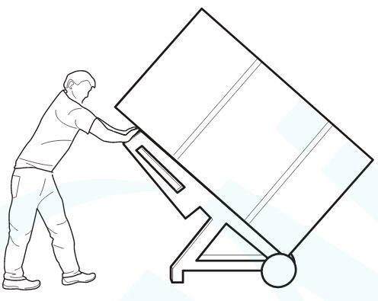

3.2 Door Disassembly and Assembly
When the whole refrigerator cannot enter the room, the door can be disassembled, then assembled after entering separately.

3.3 Installation location
Installation location
Please select a ventilated place to place the refrigerator, and reserve space according to the recommended size in the picture, which is conducive to heat dissipation, performance improvement and energy consumption reduction. | 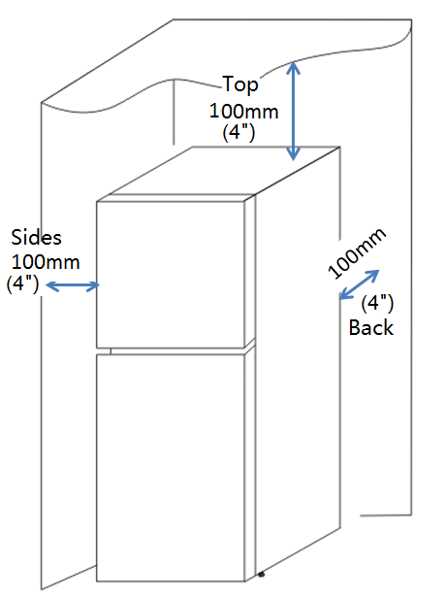

3.4 Leveling of the refrigerator
Leveling of the refrigerator
If the refrigerator cannot be placed steadily, adjust the footing to level it. Turn the feet clockwise to raise the refrigerator; turn the feet counterclockwise to lower the refrigerator. | 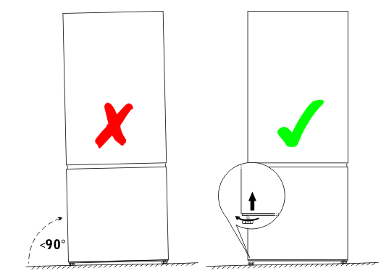

3.5 Left or right open door reversal
Door reversal
1) Power off and remove all food from the fridge.
2) Dismantle the upper hinge cover, screws and upper hinge from the right top, and remove the cover plate from the left top. | 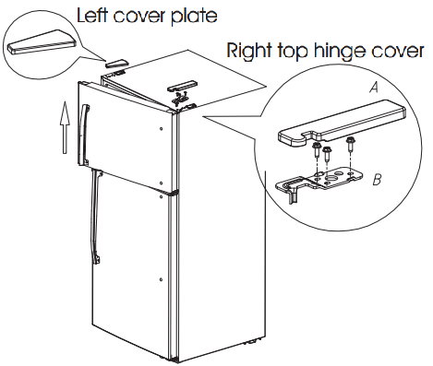
3) Take off the freezer door.  4) Unscrew the three screws holding the center hinge, remove the hinge, then lift the refrigerator door up and away from bottom hinge. | 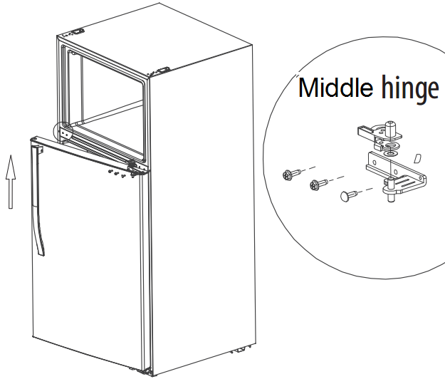
5)Remove the bottom hinge and screws.  6) Unscrew the hinge shaft from the right side of the bottom hinge and move it to the left side,  then secure the bottom hinge to the bottom left side of the refrigerator. | 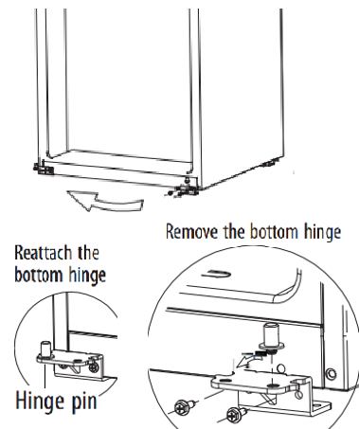
7) Dismantle the sleeves, hole cap, screws and door stopper on the refrigerator door, and assemble them on the other side. | 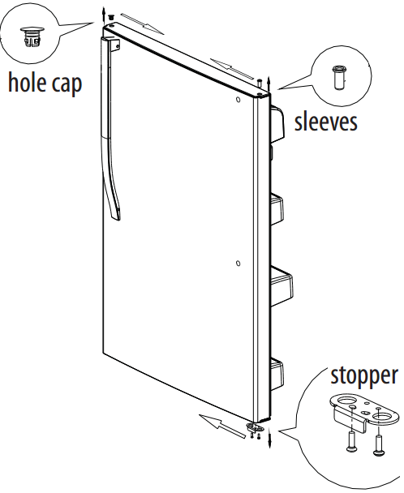
8) Dismantle the sleeves, and assemble them on the other side.  9）Remove the freezer door self-locking block and stopper, save the to reuse. Take out the left self-locking block and stopper from the accessory plastic bag in the refrigerator and installed on the left of door. | 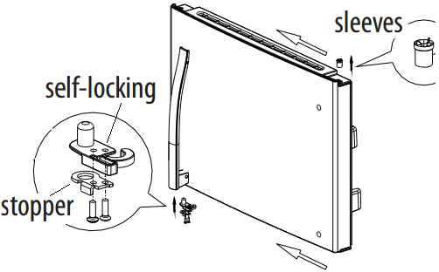
10)Put down the refrigerator door on the bottom hinge, take out the middle hinge of the other side from the accessory plastic bag, then assemble the middle hinge. | 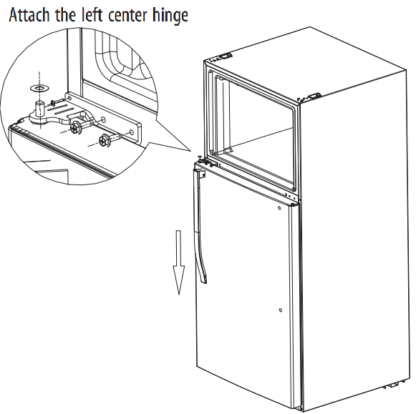
11) Put down the freezer door on the middle hinge, then take out the top hinge and cover of other side from the accessory plastic bag. Then assemble the left top hinge, hinge cover and hole cover. | 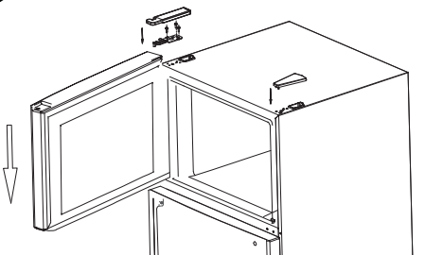  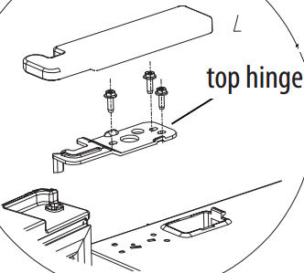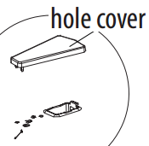

3.6 Installation of handle（Option）
Installation of handle
1)Remove the hole covers on the front of the door.  2)Take out the door handle, bolts and screw covers from the accessory plastic bag. | 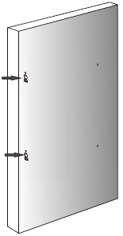
3）Fix the bolts① in the screw hole on the front of the door.  4） Install the door handle② onto the bolts.  5）Tighten the Allen screws③ in the door handle hole.  6）Install the screw cover④ on the screw of the door handle. | 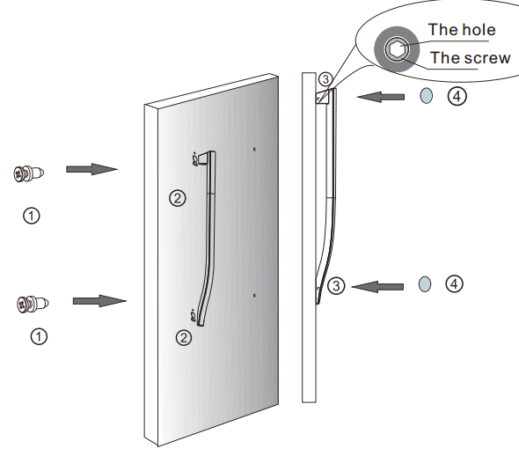

4. Main parts and external dimension

4.1 Main parts
(The picture is only for reference, and specific appearance and configuration are subject to the real product)
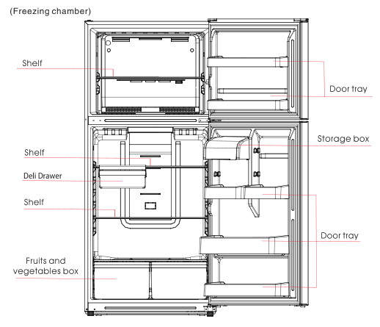

4.2 External dimension
Description | Code | Size (mm)
Height to top of Cabinet | A | 1692
Width | B | 755
Depth w/Cabinet | C | 680
Depth w/Door | D | 780
Depth w/Handle | E | \
Depth (Door open 90 deg. w) | F | 1495.5
Depth (Door open 135 deg. w) | G | 1342
Width (Door open 135 deg. w) | H | 1275
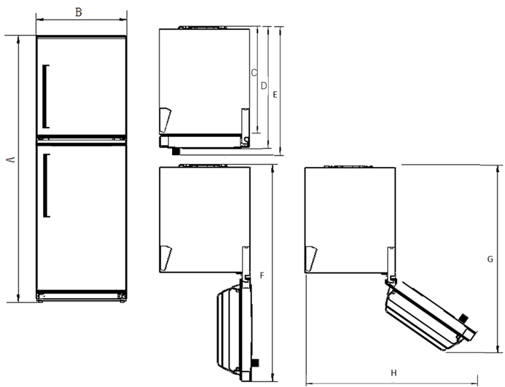
(The picture is only for reference)

4.3 Midea product serial number and location
1） Product Serial Number — Including order number, production date and other information. When the product occur problem, it needs to be recorded or photographed and provided to us.
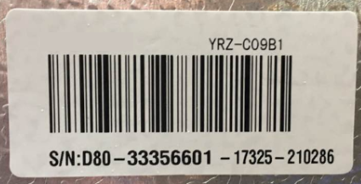
2）Paste location
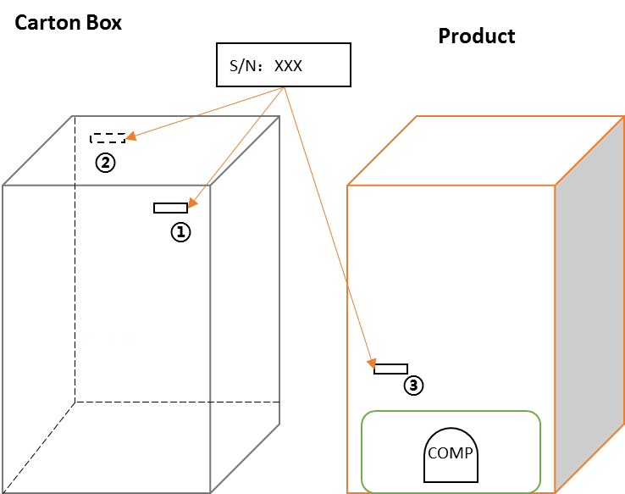
Some products also have S/N on the lower part of the right side of the Cabinet.

5. Electric control system

5.1 Electrical parts parameters
Applicable Model | HD-668FWEN
Product Model | UR-BCD512WE-SQ
Rated Voltage | 115V、60Hz
Item | Specification | Specification
Refrigerant | R600a
Compressor | EZ65H1X-UQCL(MD#)  (Part code : 11101010010152)
Starting device type | Fixed Speed
The COP of compressor | 1.85(W/W)
The max cooling capacity of compressor | 133 W
Winding resistance of compressor wiring terminal (20℃) | Rmc:7.07Ω±7%  Rsc:6.07Ω±7%  Rms = Rmc + Rsc
Winding resistance picture | 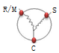
Starter(PTC) | QPE2-A4R7MD3 V  (Part co: 12031000001584)
Overload protector(OLP) | DRB26T61A1 V  (Part code : 12031000001301)
Integrate PTC+OLP | None
Variable frequency driver board | None
Capacitor | 10μF
Power filter (EMI) | None
Power reactor (EU EMC) | None
Motor
Fan motor of the freezing chamber | DC12V、2W、2300r/min
Fan motor of the refrigerating chamber | None
Electric damper | Have
Lights
Lights inside the refrigerating chamber | DC12V、2W
Lights inside the freezing chamber | DC12V、2W
Others Lights | None
Switch of the light | ■Mechanical switch  □Magnetism control switch
Defrosting parts
Defrosting sensor | NTC B3839 ( B5/25=3839K±2% )
Fuse in freezing chamber | AC115V、77(0 ～ -5) ℃
Defrost heater in freezing chamber | AC115V、215W

5.2 Circuit diagram
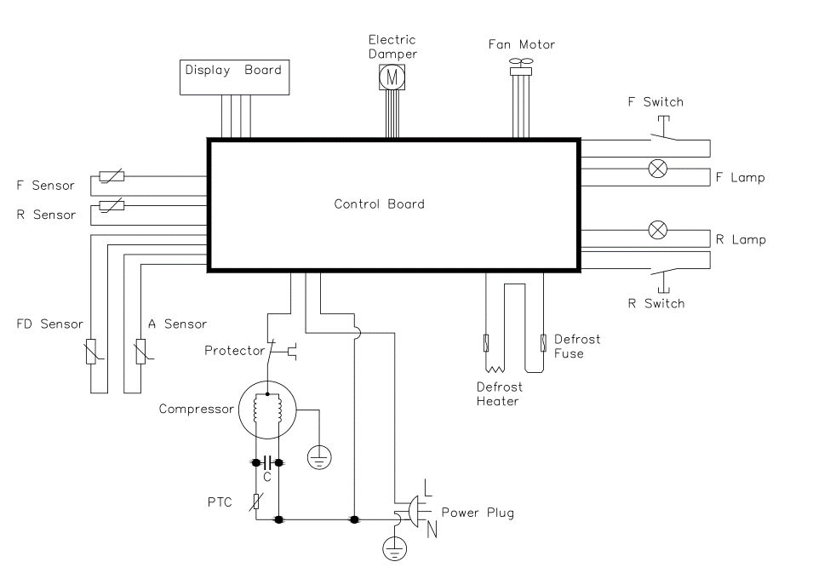
F: Freezer R: Refrigerator FD: Freezer defrost A: Ambient temperature

5.3 Main PCB terminal connection diagram
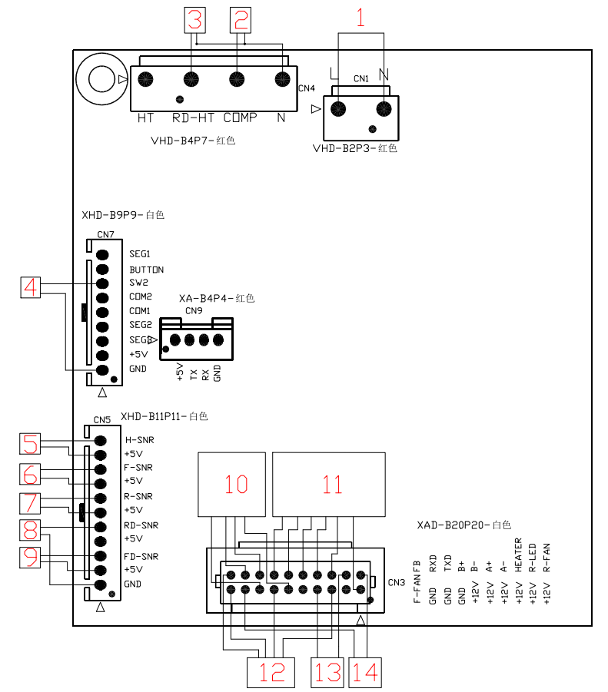
Connecting terminals | Connecting terminals
1.Power supply  2. Compressor  3. Freezing defrost heater  4. Refrigeration light switch  5. Ambient temperature sensor  6. Freezing temperature sensor  7. Refrigeration temperature sensor | 8. Freezing light switch  9. Freezing defrost sensor  10. Display control panel  11. Electric damper  12. Fan of freezing chamber  13. LED of freezing chamber  14. LED of refrigeration chamber

6. Refrigeration system

6.1 Refrigeration system working principle
❶Compressor→❷ Anti-condensation tube→❸ Condenser→❹ Dry filter→❺ Capillary tube→❻ Evaporator→❼ Suction tube→❶Compressor
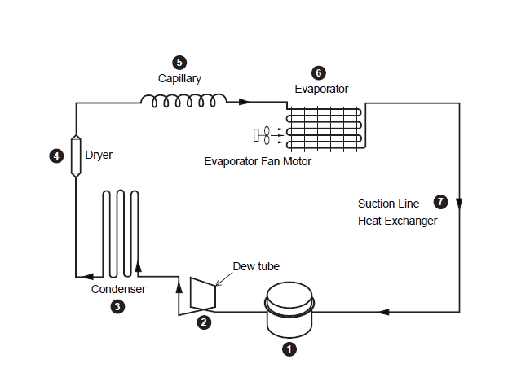

6.2 Cooling pipeline and drain pipe inside the cabinet
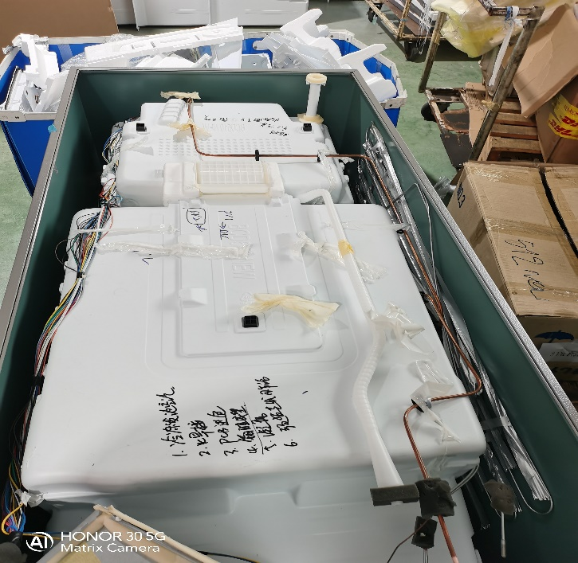

6.3 Circulating route of cooling air
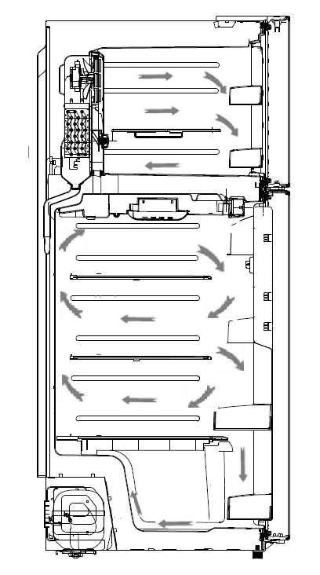

6.4 Welding points in chambers or foam layer
1) Welding points on freezer evaporator | 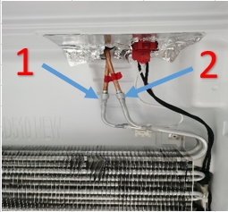
Welding point | Pipe outer diameter (mm)
1-Freezer capillary and inlet of evaporator | Copper pipe: Φ6 | Aluminum pipe: Φ6.0
2-Heat transition tube and outlet of evaporator | Copper pipe: Φ6 | Aluminum pipe: Φ6.0

6.5 Welding point in the compressor case
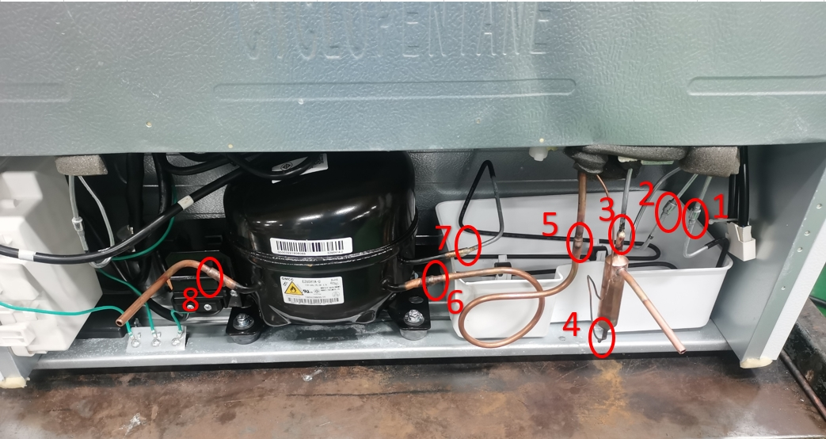
Welding point | Pipe outer diameter (mm)
1-Inlet of anti-condensation tube and outlet of venting connection tube | Steel pipe: Φ4.0 | Steel pipe: Φ4.0
2-Inlet of condenser tube and outlet of anti-condensation tube | Steel pipe: Φ4.0 | Steel pipe: Φ4.0
3-Outlet of left condenser tube and inlet of dry filter | Steel pipe: Φ4. 0 | Copper pipe: Φ5.0
4-Outlet of dry filter and inlet of freezer capillary | Copper pipe: Φ2.8 | Copper pipe: Φ1.8
5-Heat transition tube and Suction connection tube | Copper pipe: Φ6.0 | Copper pipe: Φ6.0
6-Suction connection pipe and compressor intake tube | Copper pipe: Φ6.0 | Copper pipe: Φ8.16
7-Compressor outlet tube and inlet of venting connection tube | Copper pipe: Φ6.16 | Steel pipe: Φ4.0
8-Compressor process tube and refrigerant filling tube | Copper pipe: Φ8.17 | Copper pipe: Φ6.0

7. Dismantling of parts

7.1 Parts on the door
Door seal
Door seal is installed into door liner groove.
1)Open the refrigerator door;
2)Take the door seal out of door liner;
Door tray
While squeezing it inward, lift up the door tray and take it out from door liner. | 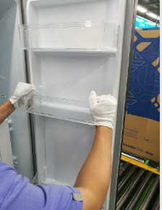
Door stopper
After removing the door, remove the fixing screws at the position shown in the figure, remove the door sleeve pipe and stopper, and complete the stopper replacement.

7.2 Parts inside the refrigerator
Refrigerator Fruit box cover
Remove the crisper cover of ref. compartement according to below steps:  - 1）Take out the crisper firstly.  - Lift up the Fruit box cover, and then pull out it. | 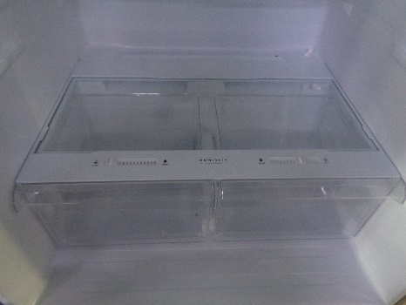
Shelves
Lift up the division plate with a proper force and pull it out towards yourself; | 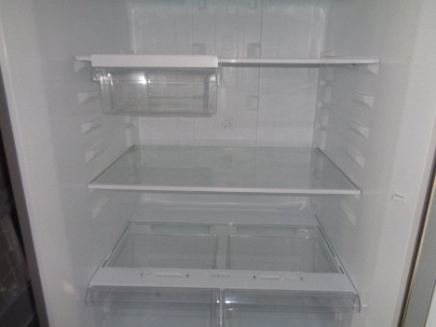
Freezer Drawer
None | None

7.3 Light system
Light
Light of the refrigerating
1）Remove the lamp cover | 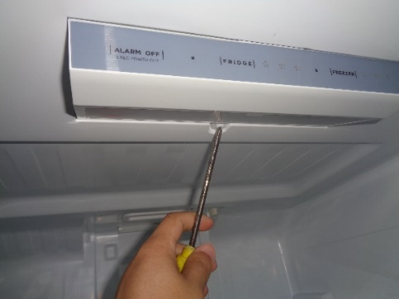
2）Remove the light.  3) The reverse process can complete installation. | 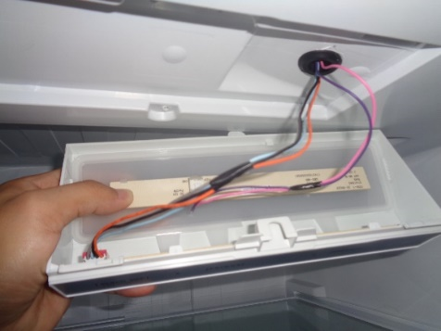
Light of the freezing
1）Remove the lamp cover
2）Remove the light.
3) The reverse process can complete installation.

There is a light switch on the side wall of the cold room and the cold room.1）Loosen the hook with small normal screwdriver and pull out the switch until the wire connector reveals. | 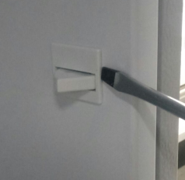  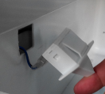

7.4 Air duct components refrigerating chamber and fan motor
Air duct components in freezing chamber
- The refrigerator air duct components is located on the back of the refrigerating chamber.
- use slotted screwdriver to dismanlte the deodorizer box. then use cross screwdriver to remove the fittin screw of air duct cover
3）use fingers to hold the button edge of air duct cover and pull it outwards with big strength
Fan motor of air duct
None

7.5 Air duct components in freezing chamber and fan motor
Air duct components in freezing chamber
All accessories in the freezing chamber should be dismantled before removing the air duct components.  1）Remove 2 screws on the cover plate of the freezing air duct using a cross screwdriver | 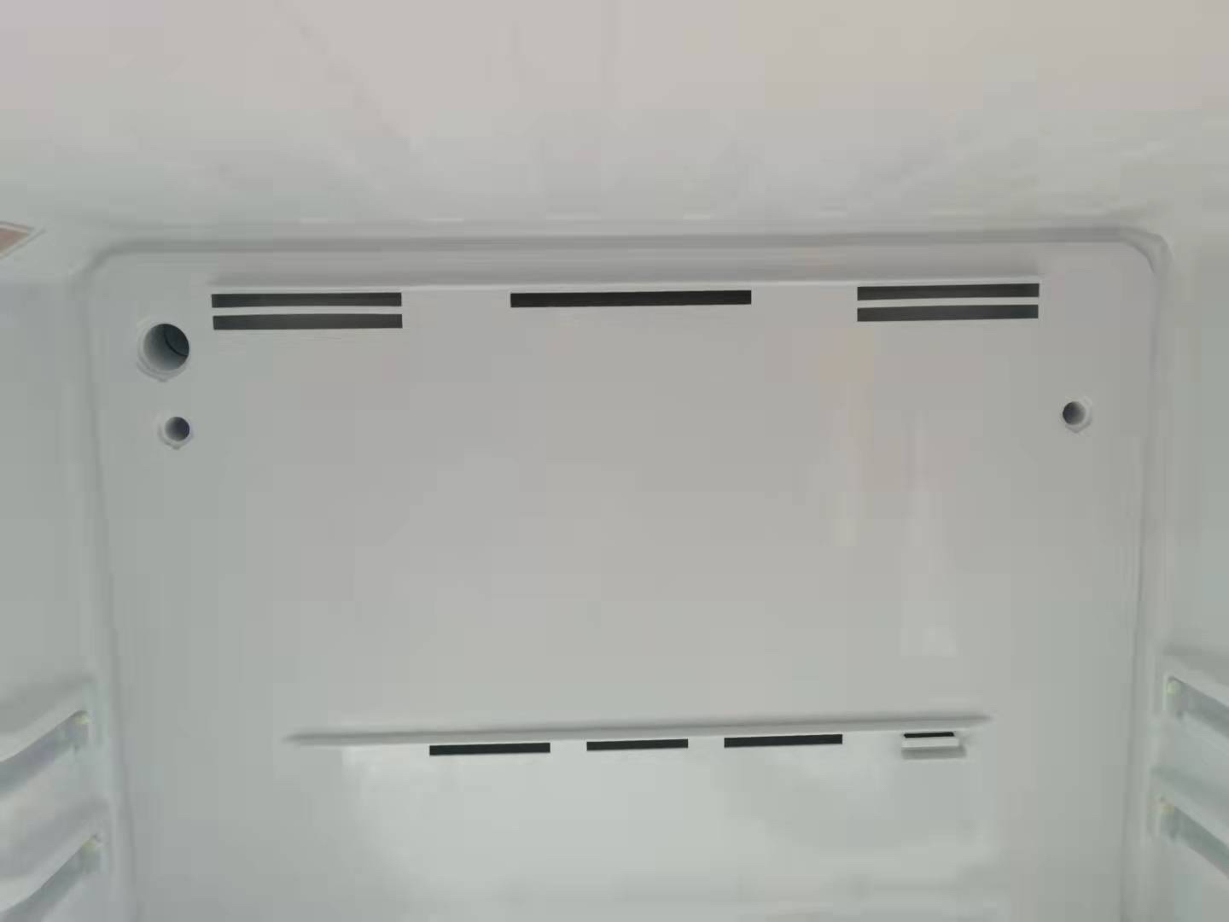
2）Hold the middle position upper of freezer air duct, raise it then pull it outwards gently. | 
3）Pull out the connector terminal.
4)Take out the freezing air duct assembly.
Fan motor of air duct
Pull buckles at the back of the freezing air duct and remove 2 front cover plates;
Replace the fan in reverse steps;

7.6 Evaporator and Defrost system
Evaporator in freezing chamber
1）Remove the air duct components in freezing and variable temperature chamber.  2）Disconnect all connecting terminals.  3）Remove the welding on inlet and outlet tubes.  4）Remove the evaporator. | 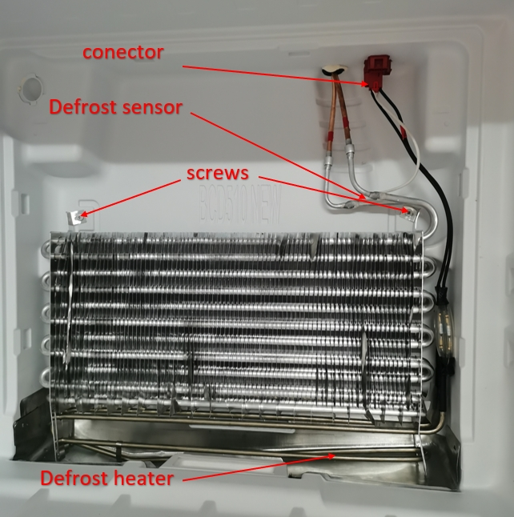
Components on the evaporator
Defrost heater with defrost sensor and fuse, it can be replaced separately.  - Cut off wiring terminal  - Cut off the band which fixes the sensor  - Cut off the band which fixes the fuse  - Separate the sensor and the evaporator  - Take off the defrost heater from the supporting plate of evaporator | 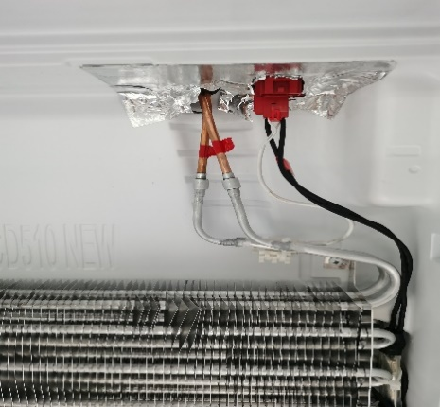  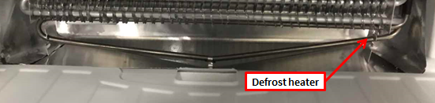

7.7 Compressor case
Rear cover
 | None
Piping and parts in the compressor case
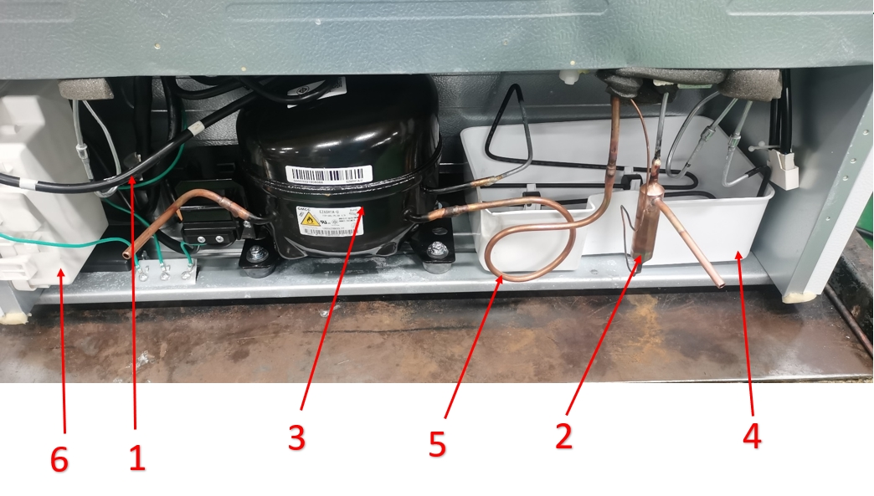
1-Power cord  2-Dry filter  3-Compressor | 4-Drain tray 1  5-Suction connection tube  6-Drain tray 2
Disassembly and assembly of compressor
1）Cut off the power, remove the goods in the refrigerator, with the tape to make the door fixed firmly and prevent the door dropping when the refrigerator dumping. | 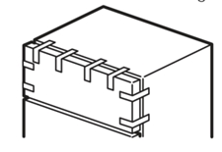
2）Slowly tilt the refrigerator forward, relying on the wall or a solid enough object, leaving space to facilitate the operation. For safety, it should be carried by someone to prevent its falling. | 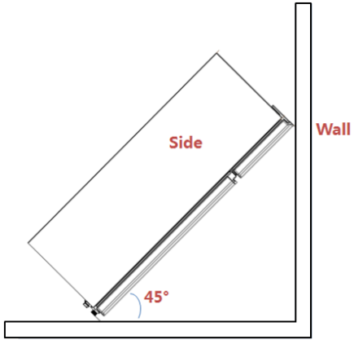
3）Cut off the compressor pipeline.-❶Cut off the process pipeline.-❷Cut off the low-pressure muffler.-❸Cut off the high-pressure exhaust pipe. | 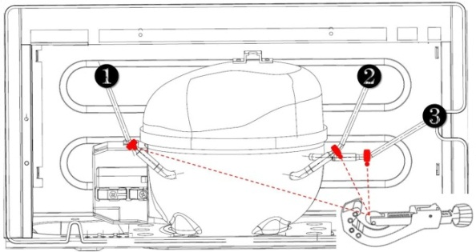
4-1）Remove the screws(for some models)  -Two screws outside  -One screw inside | 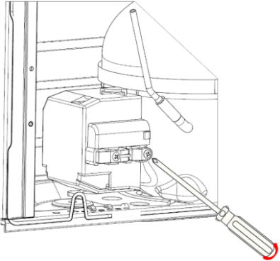
4-2）Remove the metal clamp(for some models)  -Disassembly the metal clamp that is fix the electric appliance shield | 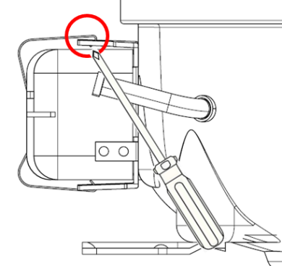
5）Remove the clipping strip  Slowly pull it out | 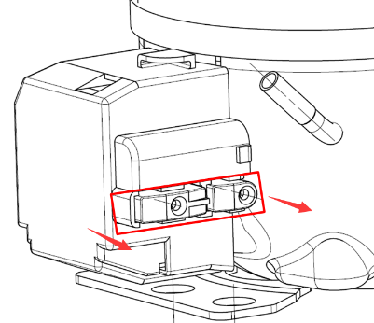
6）Remove the protective cover  -Pry the protective cover slowly from the upper part,  -Pull it out and remove it. | 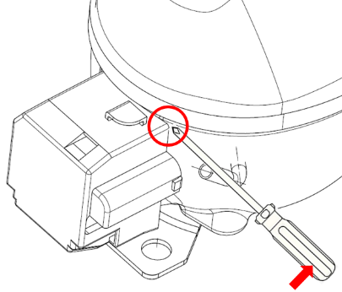
7）Remove the starter and protector  Unplug the starter and protector (you can use a screwdriver to pry it slowly) | 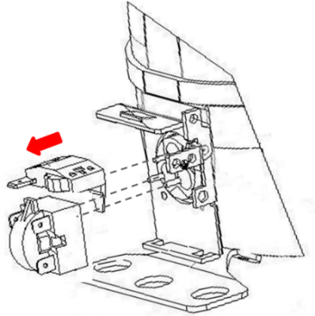
8）Loosen the screw of the compressor bottom plate, remove the floor together with the compressor from the box. | 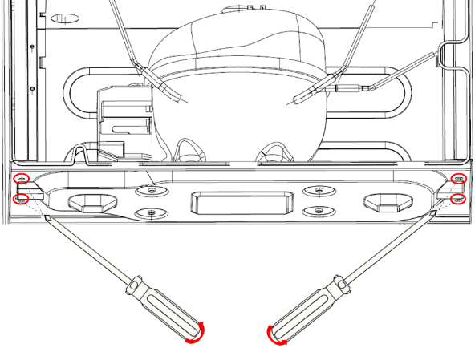
9）Use the wrench to remove the bolts by steps❹❺❻❼, replace the compressor and reverse process can complete installation. | 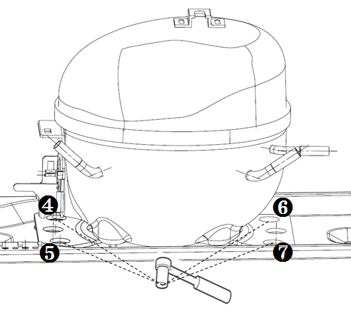
10）Use Pipe cutter cut off the condenser tube❽, then Shear off capillary ❾ by the capillary tube scissors. | 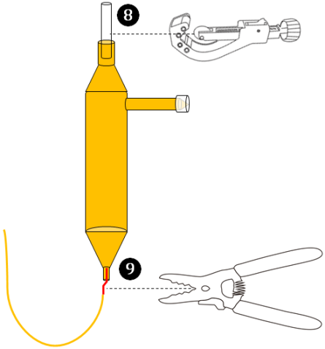
11）Replace the compressor and welding the compressor pipeline.-❿Welding the process pipeline.-⓫Welding the low-pressure muffler.-⓬Welding the high-pressure exhaust pipe. | 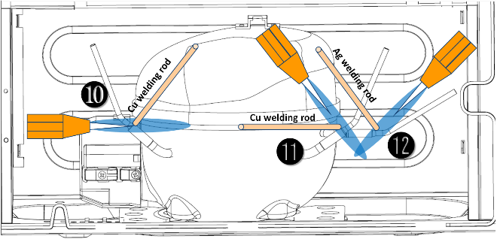
12）Replace the filter, Cu-Fe tubes welding ⓭ used Ag welding rod, Cu-Cu tubes welding⓮ used Cu welding rod. | 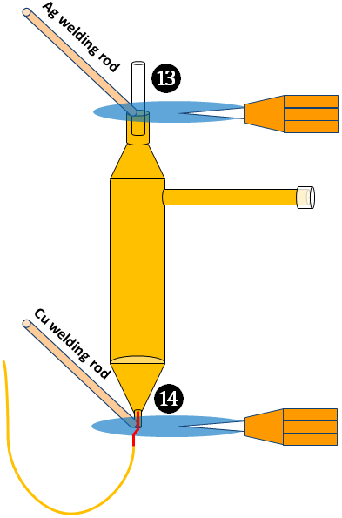
13）Vacuum system,The degree of vacuum below 6Pa. | 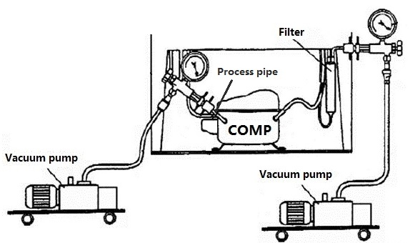
14）Perfusion refrigerant. | 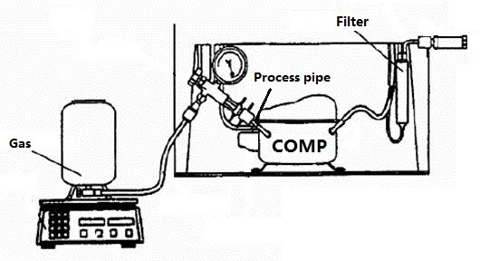
15）Use the vise grip pliers clamp the middle of the process pipe, then seal welding process tube⓯⓰. | 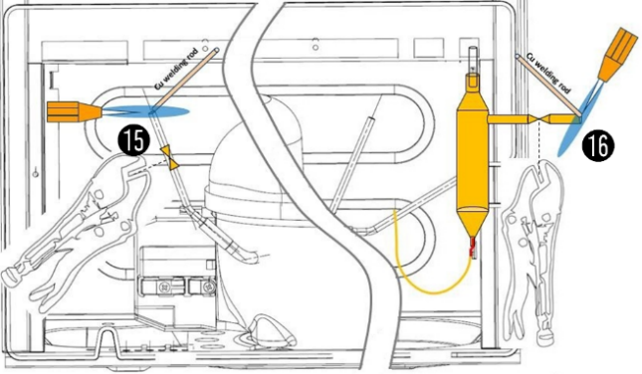

7.8 Display control board
Display control board
1)Remove one screw using a Phillips screwdriver | 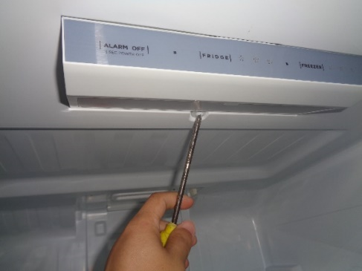
2）Remove the terminal and the display board. | 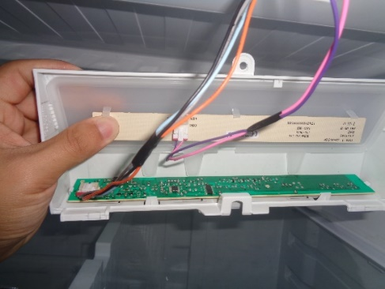

7.9 Main control board
1) Remove the two screws that secure the main control board box. | 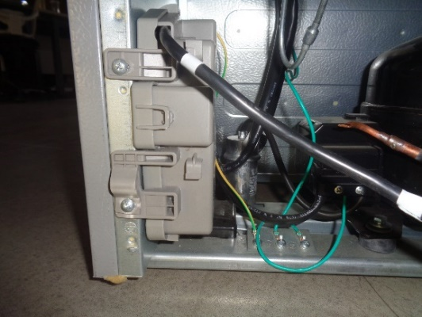
2) Take out the mounting box, pry up the cover, disconnect the wiring terminal. | 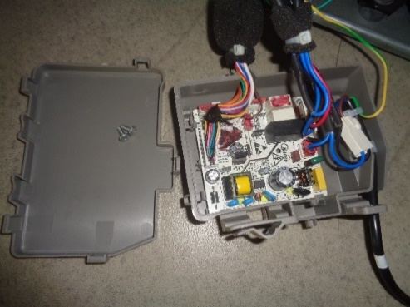
The connecting terminals remove：
- Use a needle tool to remove the lock at the arrow and remove the lock upward
- After the lock is removed, press the hook to remove the wiring connectors
5）Disconnect the wiring terminal, take out the main control board, and complete the replacement. | 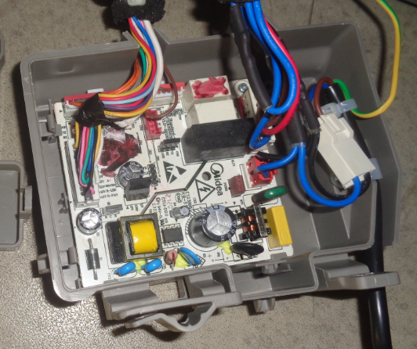

8. Temperature sensing system

8.1 Position of sensors
Position of sensors
Have 3 sensors  ② Sensor in refrigerating chamber  ④ Ambient temperature sensor  ⑦ Defrost sensor in freezing chamber  ⑨ Freezer sensor | 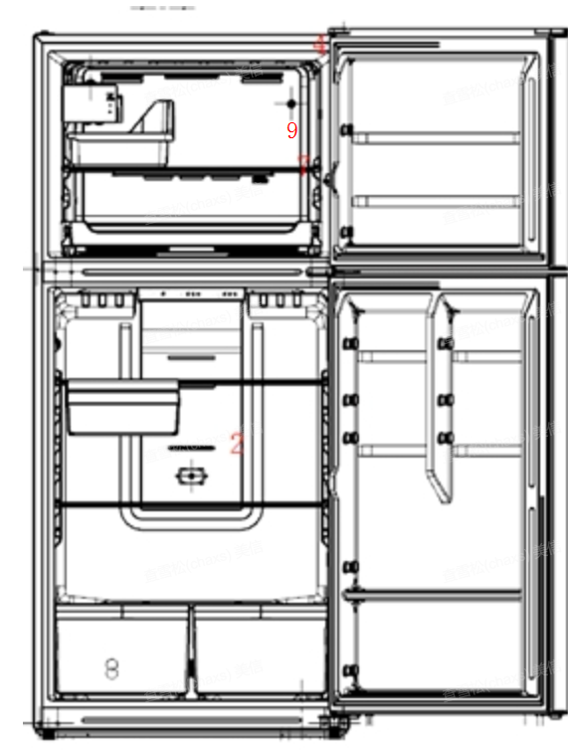

8.2 Replacement of sensors
Sensor in refrigerating chamber
The refrigerating air duct components should be dismantled before removing this sensor.
1) Strip the tape that secures the wiring harness.
2) Then remove the sensor.
Ambient temperature sensor
The sensor is located in the hinge cover of the refrigerator top. | 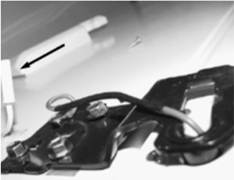
Defrost sensor in freezing chamber
- Cut off wiring terminal;  - Cut off the band which fixes the sensor; | 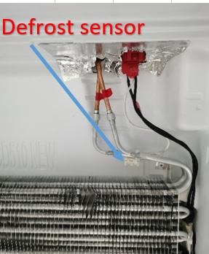
Freezer sensor
1)Remove the air duct assembly of freezer(two screws);  2)Remove the air duct front plate;  3)Then remove the sensor. | 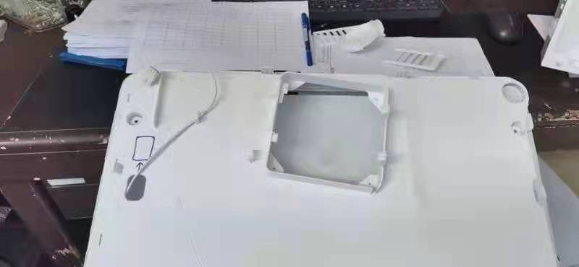

8.3 Sensor without terminal replacement
Sensor replacement guidelines
Cut off the damaged head of sensor. | 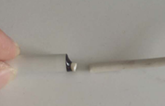
Strip off the sensor wiring. | 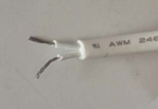
Take out a new sensor to cut the head of sensor.  (Spare parts code：11201007000795) Its technical specifications apply to all MIDEA refrigerators. | 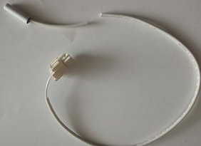
Strip off the head of the sensor and connect it. | 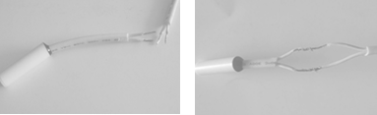
Wrap the two wires together with insulation tape. | 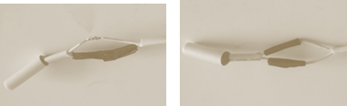
Wrap the two wires together. | 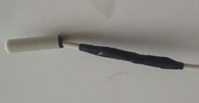

8.4 Sensor R/T table
Tx(℃) | Tx(℉) | R（KΩ） | Tx(℃) | Tx(℉) | R（KΩ） | Tx(℃) | Tx(℉) | R（KΩ）
-30 | -22.00 | 33.81 | -5 | 23.00 | 8.392 | 20 | 68.00 | 2.501
-29 | -20.20 | 31.85 | -4 | 24.80 | 7.968 | 21 | 69.80 | 2.391
-28 | -18.40 | 30.01 | -3 | 26.60 | 7.568 | 22 | 71.60 | 2.287
-27 | -16.60 | 28.29 | -2 | 28.40 | 7.190 | 23 | 73.40 | 2.188
-26 | -14.80 | 26.68 | -1 | 30.20 | 6.833 | 24 | 75.20 | 2.094
-25 | -13.00 | 25.17 | 0 | 32.00 | 6.495 | 25 | 77.00 | 2.005
-24 | -11.20 | 23.76 | 1 | 33.80 | 6.175 | 26 | 78.80 | 1.919
-23 | -9.40 | 22.43 | 2 | 35.60 | 5.873 | 27 | 80.60 | 1.838
-22 | -7.60 | 21.18 | 3 | 37.40 | 5.587 | 28 | 82.40 | 1.761
-21 | -5.80 | 20.01 | 4 | 39.20 | 5.315 | 29 | 84.20 | 1.687
-20 | -4.00 | 18.90 | 5 | 41.00 | 5.060 | 30 | 86.00 | 1.617
-19 | -2.20 | 17.87 | 6 | 42.80 | 4.818 | 31 | 87.80 | 1.550
-18 | -0.40 | 16.90 | 7 | 44.60 | 4.589 | 32 | 89.60 | 1.486
-17 | 1.40 | 15.98 | 8 | 46.40 | 4.372 | 33 | 91.40 | 1.426
-16 | 3.20 | 15.12 | 9 | 48.20 | 4.167 | 34 | 93.20 | 1.368
-15 | 5.00 | 14.310 | 10 | 50.00 | 3.972 | 35 | 95.00 | 1.312
-14 | 6.80 | 13.550 | 11 | 51.80 | 3.788 | 36 | 96.80 | 1.259
-13 | 8.60 | 12.830 | 12 | 53.60 | 3.613 | 37 | 98.60 | 1.209
-12 | 10.40 | 12.160 | 13 | 55.40 | 3.447 | 38 | 100.40 | 1.161
-11 | 12.20 | 11.520 | 14 | 57.20 | 3.290 | 39 | 102.20 | 1.115
-10 | 14.00 | 10.920 | 15 | 59.00 | 3.141 | 40 | 104.00 | 1.071
-9 | 15.80 | 10.350 | 16 | 60.80 | 2.999 | 41 | 105.80 | 1.029
-8 | 17.60 | 9.820 | 17 | 62.60 | 2.865 | 42 | 107.60 | 0.989
-7 | 19.40 | 9.316 | 18 | 64.40 | 2.737 | 43 | 109.40 | 0.951
-6 | 21.20 | 8.841 | 19 | 66.20 | 2.616 | 44 | 111.20 | 0.914

9. Function and operation

9.1 Display operation panel
Refrigeration chamber temperature control panel
Button | Icons
A. Freezing chamber temperature gear setting | ① Gear 1 (LED3)  ② Gear 2 (LED2/3)  ③ Gear 3 (LED1/2/3)
B. Refrigerating chamber temperature gear setting | ① Gear 1 (LED6)  ② Gear 2 (LED5/6)  ③ Gear 3 (LED4/5/6)
C. ALARM set OFF | ① Cancel alarm tone  ② Standby mode (Fridge stop working)
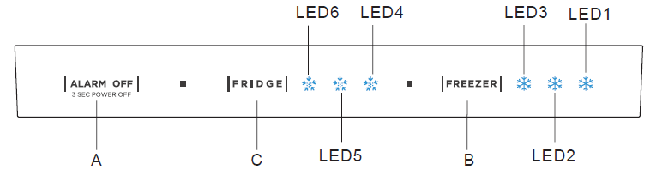

9.2 Temperature control
9.2.1 Temperature setting of refrigerating chamber
Press the gear setting button ‘SET’ once, the gear will be changed once, 5 seconds after setting the gear, the refrigerator will be running in accordance with the set value.
Temperature gear of refrigerator chamber | Gear 1 | Gear 2 | Gear 3
Temperature value | 8℃ | 4℃ | 2℃

9.2.2 Temperature setting of freezing chamber
Temperature gear of freezer chamber | Gear 1 | Gear 2 | Gear 3
Temperature value | -16℃ | -19℃ | -24℃

9.3 Mode setting
9.3.1 Standby mode setting
1）When the refrigerator is working, keep pressing the “” button for 3 seconds, the refrigerator will stop working.
2）When the refrigerator is in standby mode, keep pressing the “” button for 3 seconds, the refrigerator will operate normally.
9.3.2 Locking and unlocking (None)

9.4 Defrosting function
◆ Defrosting theory:
The defrosting of evaporator is realized by the heating of heater, following the temperature rise, the frost on evaporator becomes water, and the water flow into the evaporating pan via the draining system, the water in evaporating pan evaporate away finally
◆ Defrosting steps:
The fan motor stop work--- Compressor shutdown--- the heater start working ---the heater stop when the temperature rise to setting--- after 7 minutes, if the start-up condition is reached, the compressor will start--- after 3 minutes, the fan motor will start work
◆ Meet one of the following conditions , defrost heating exit:
- When the frozen defrosting sensor has no fault, the measured temperature Tfd ≥ the set temperature which defrost heating exit
- When the frozen defrosting sensor has no fault, the defrosting time is ≥ 60 minutes
- When the frozen defrosting sensor is faulty , the heater will stop after work 20 minutes

9.5 Open door alarm (None)

9.6 Error code and solutions
Error code | Fault Type | Troubleshooting and Solutions
LED① and LED② together lighten | Refrigerator chamber sensor failure (E1) | Step 1: Check whether the connection terminals are plugged in place and whether there are foreign matters in them; after cleaning the terminals, plug them in again.  Step 2: If the fault still occurs, pull out the corresponding connection terminal on the main PCB, use a multimeter to check the resistance value of the sensor, and confirm whether it is normal.  Step 3: If the resistance value is wrong, replace the sensor.  Step 4: If the fault still occurs, replace the main PCB.
LED① and LED③ together lighten | Freezer defrost sensor failure(E5)
LED① and LED④together lighten | Ambient temperature sensor failure (E7)
LED② and LED④together lighten | Communication failure  (E6)
LED① and LED⑤together lighten | Freezing chamber sensor failure(E2)

9.7 Test mode
Test items | Setting Method | Setting result
Enter Test Mode | Keep pressing the Freezing and Refrigerating chamber gear setting button for 3 seconds and release | 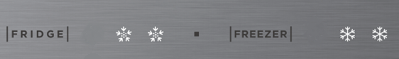
Select to enter into forced defrosting mode in all rooms | Press the "freeze" button to adjust and select the mode, as shown in the picture on the right; The lock takes effect. | 
 | In forced defrosting mode, when the freezing defrosting sensor reach a temperature of 8°C and the defrosting heater has been working for at least 3 minutes. | then the refrigerator will exit the test mode and return to normal operation mode
 | In forced defrosting mode, if the defrosting heater has been working for 60 minutes, | then the refrigerator will exit the test mode and return to normal operation mode
Select to exit the test mode | In test mode, power off or enter standby mode | The refrigerator will exit the test mode
 | Keep pressing the Freezing and Refrigerating chamber gear setting button for 3 seconds and release | 
 | After entering the test mode, press the "freeze" button to adjust the mode selection mode, as shown in the picture on the right; The lock takes effect. | 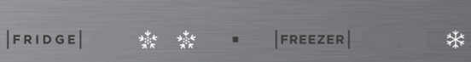
Control rules for forced cooling mode:
1, the compressor is the most high-grade operation;
2, the highest grade operation of the refrigeration fan;
3, air door open;
Exit mode after 72 hours.
In the forced mode, press the cold temperature adjustment button and the cold temperature adjustment button for 3s, lock and exit

9.8 Demo mode（None）

9.9 Backup data for power fail
- The running state of the refrigerator is remembered after compressor running for 1 hour continuously.
- The running state of the refrigerator is remembered after change function settings and lock.
- When the refrigerator is out of power and recharged, the running state of the refrigerator is same as before.

10. Compressor

10.1 Compressor on and off control specifications
  - When one of the following conditions is met, the compressor stops:
- Measured temperature in Freezing chamber ≤ Shutdown temperature of Freezing chamber
- Enter defrosting cycle
- The compressor runs continuously for more than 5 hours, will stop at least 10 minutes
1.2 When compressor shutdown time has been more than 10 min, one of the following conditions is met, the compressor starts up:
- Measured temperature in Freezing chamber ≥ Start up temperature of Freezing
- Refrigerator is set to forced cooling mode
★When 1.1 and 1.2 are not satisfied, the compressor maintains the original state

11. Troubleshooting Method

11.1 No cooling (Air cooling-Electronic)
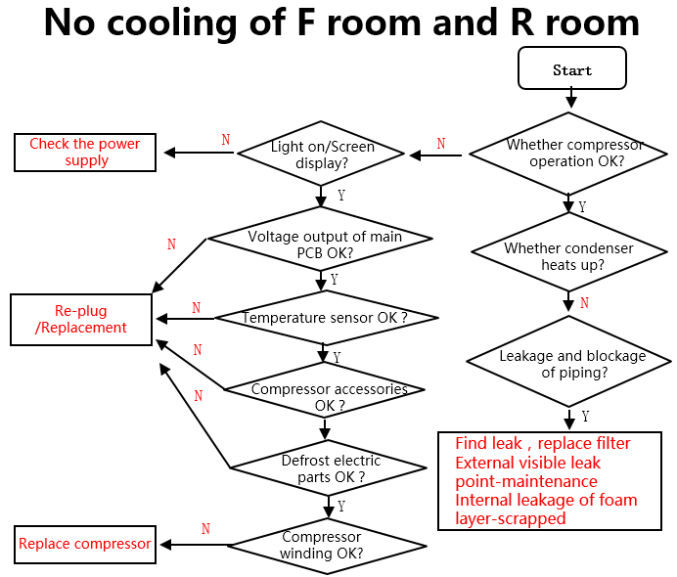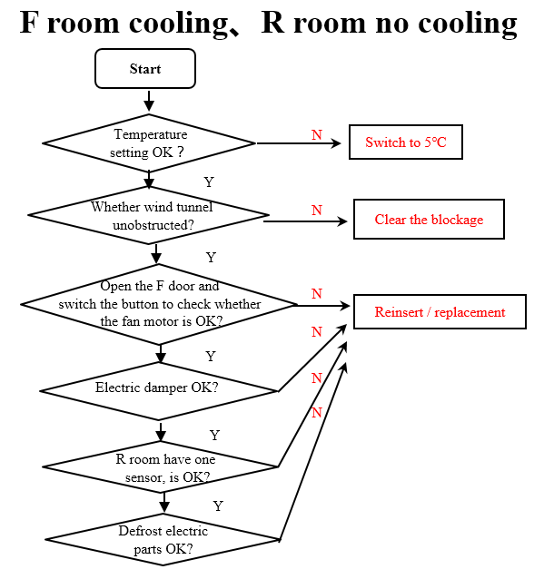

11.2 No working of compressor
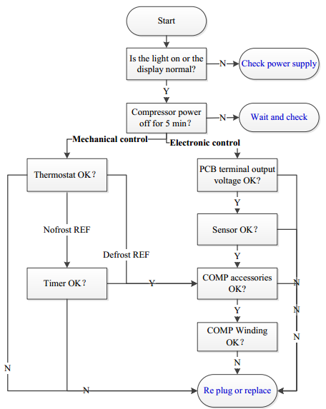

11.3 Inside frosting, no defrosting
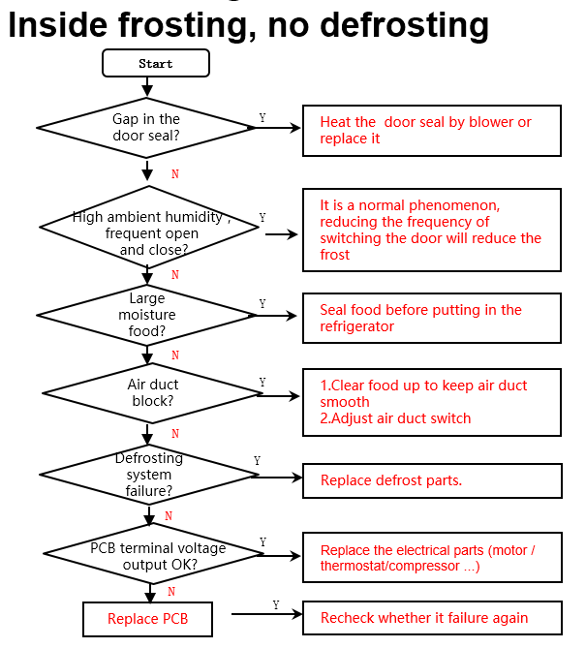

11.4 Inside frosting, no defrosting-Maintenance guidelines
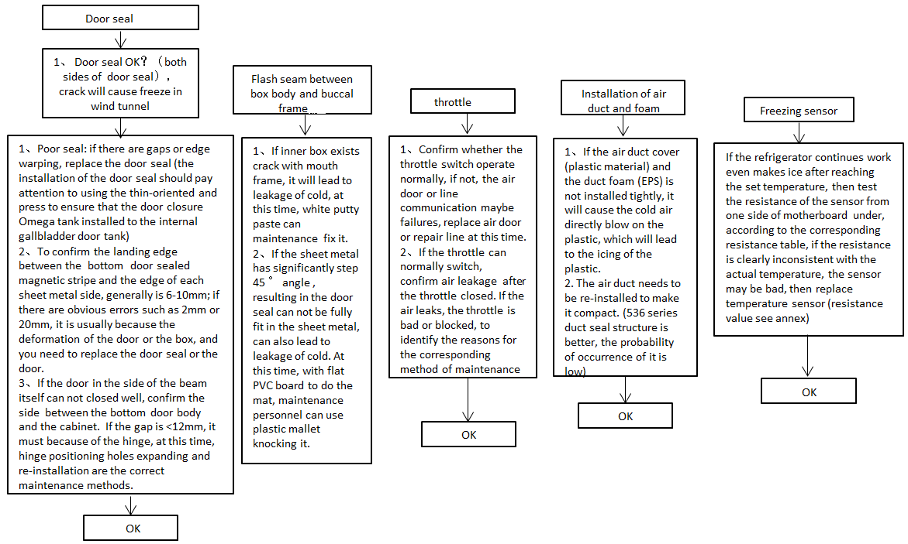
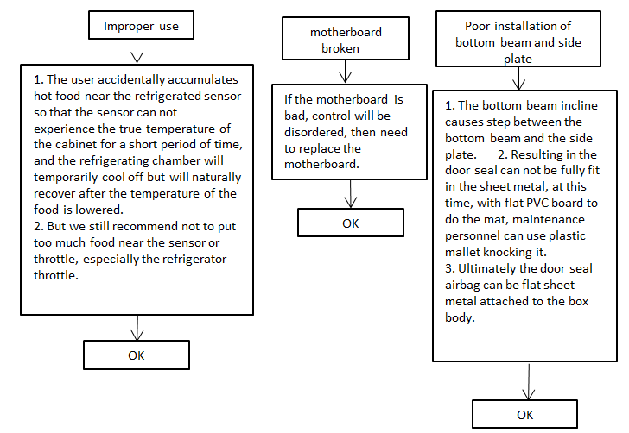

11.5 Light is not on
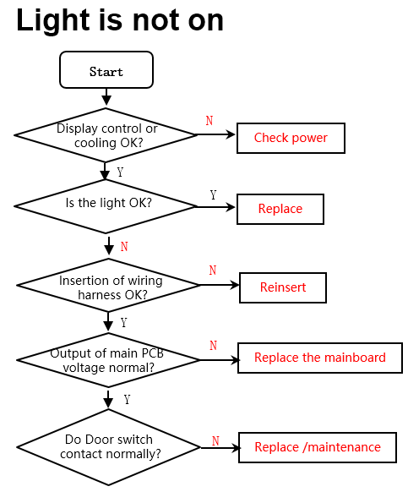

11.6 Fan failure
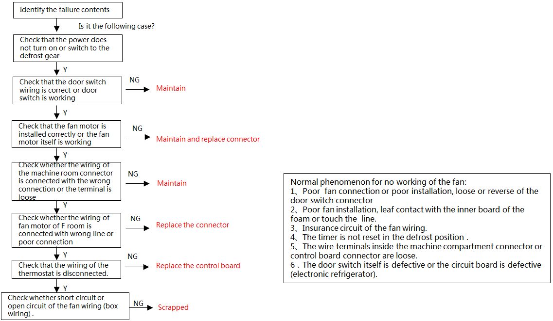

11.7 Defective defrost circuit
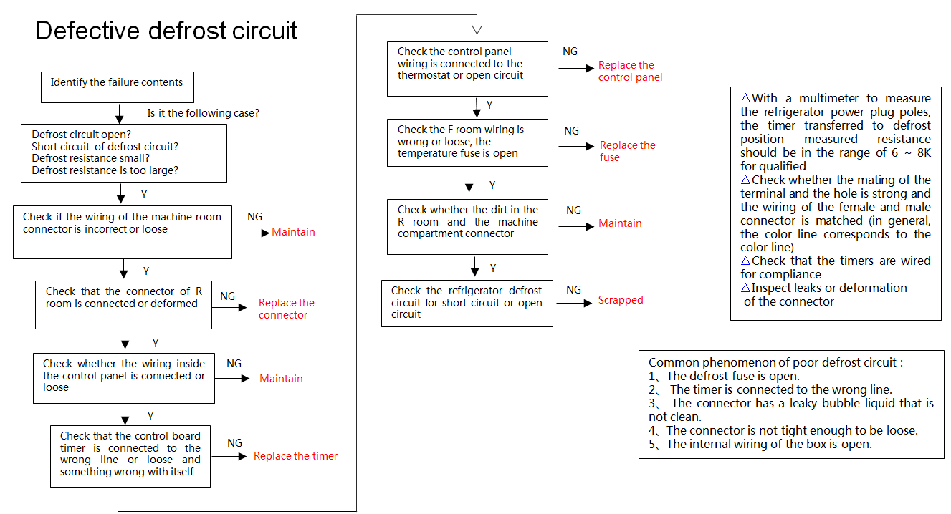

11.8 Noise
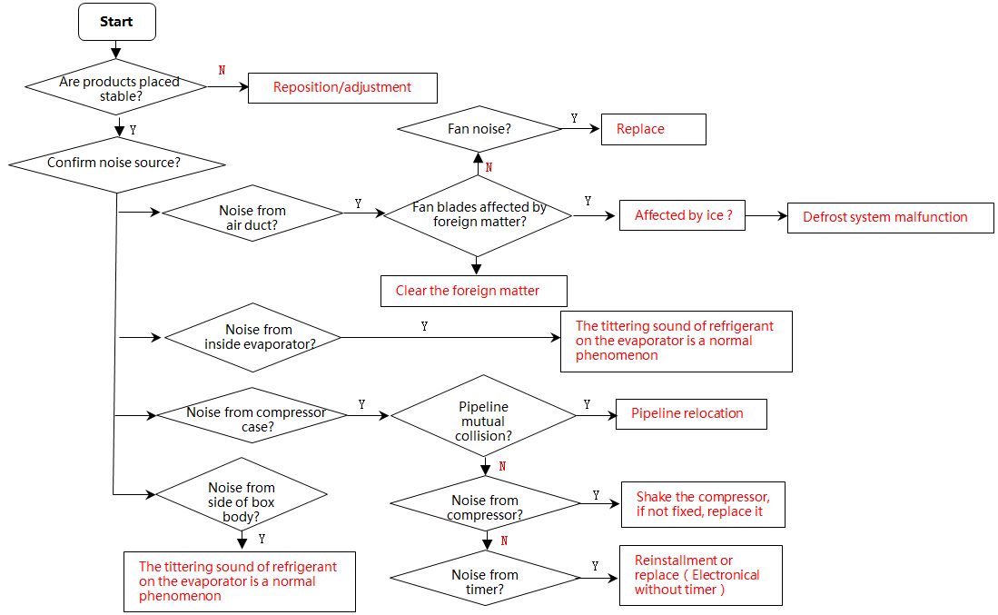

11.9 Air duct not operated
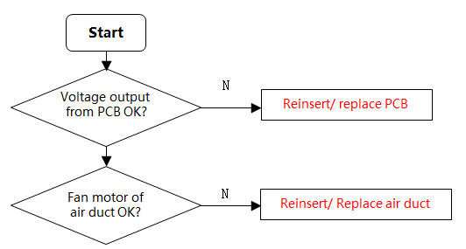

12. Product exploded view and spare parts list
Please log in to TSP system to view and download these contents.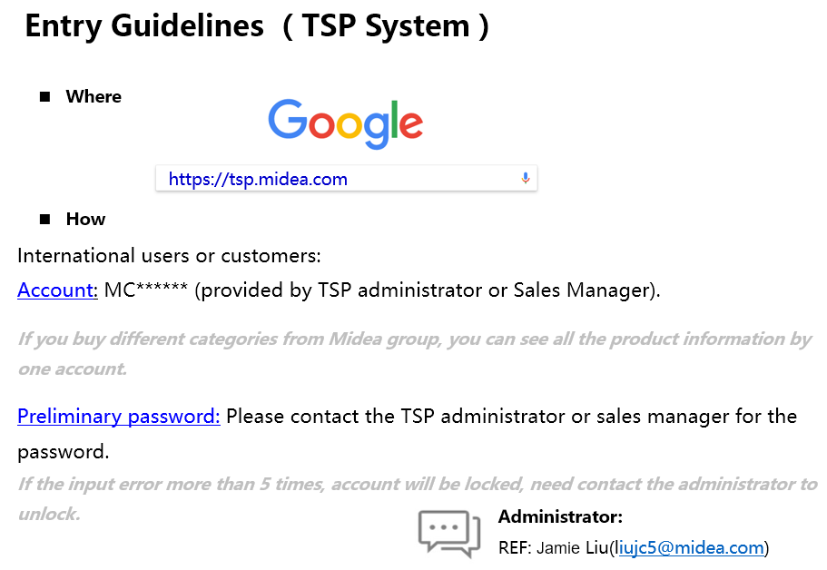

The symbol on the product or its packaging indicates that this product must not be disposed of with your other household waste. Instead, it is your responsibility to dispose of your waste equipment by handing it over to a designated collection point for the recycling of waste electrical and electronic equipment. The separate collection and recycling of your waste equipment at the time of disposal will help conserve natural resources and ensure that it is recycled in a manner that protects human health and the environment. For more information about where you can drop off your waste for recycling, please contact your local authority, or where you purchased your product.

Midea Refrigerators
If you need to get detailed technical information from the manufacturer, please contact:
xxx@midea.com
Refrigeration Division
Overseas Sales Company
Address: No. 176, Jinxiu Avenue, Economic-Technological Development Area, Hefei, Anhui, China

